Visoka škola strukovnih studija za informacione i komunikacione tehnologije u Beogradu

Visoka ICT škola

Web programiranje 1 – Dokumentacija za sajt

Ime I prezime studenta: Jovana Ćirić

Broj indeksa: 110/21

Decembar 2022, Beograd

Sadržaj:

1. Uvod
   1. Korišćeni programski i markup jezici
   2. Opis funkcionalnosti
   3. Template
   4. Korišćeni CSS
2. Organizacija
   1. Organizaciona šema
   2. Mapa sajta
   3. Stranice
3. Kodovi

# Uvod

Sajt je rađen za predmet Web Programiranje 1, napravljen na temu o Hari Poteru. Sajt je Responsive .

1.1. Korišćeni programski i markup jezici

HTML, CSS, Javascript

Koriscene biblioteke

JQuery (JavaScript)

JQuery plug-in

Flexslider (<http://flexslider.woothemes.com/?fbclid=IwAR0Ds6ggD2FBssaq4-Zu11prgVTJbfqnWg1mR9uSP41icKH3_FxwG5KfppY>)

Okruženje

Visual Studio Code

1.2 Opis funkcionalnosti

**Stranica index.html**

Dinamičko ispisivanje

Meni u hederu I futeru ispisan je dinamički preko JavaScript-a.

Ispisani delovi filmova od prvog do sedmog dela sa nazivima I slikama.

Glasanje (JavaScript) – ispisani su svi elementi dinamički

Obrađene greške u slučaju ne glasanja.

Ispisane poruke u zavisnosti od rezultata glasanja.

Kada se ispravno čekira, ispisuju se čekirani elementi I dugme za glasanje se sakriva.

**Stranica hogwarts.html**

Takođe ispisan meni I u hederu I u futeru dinamički.

Deskripcija(History of Hogwarts) ispisana dinamički preko JavaScript-a.

Preko JavaScript dinamičko ispisivanje tabele.

Preko JQuery-a uradjena zebra na tabeli. Svaki drugi red je obojen drugom bojom.

**Stranica gallery.html**

Takođe ispisan meni I u hederu I u futeru dinamički.

Slike su ulistane dinamički preko JavaScript-a.

Napravljen slajder slika pomoću plug-in-a preko Jquery-a, korišćen je flexslider da nakon pet sekundi menja slike, I kada dodje do poslednje slike, da vrati na prvu sliku. U sebi sadži strelice za prethodnu I sledeću I bullete koji stoje ispod slika I ukazuju na trenutnu sliku

**Stranica contact.html**

Dinamičko ispisivanje

Takođe ispisan meni I u hederu I u futeru dinamički.

Padajuća lista (JavaScript) – ispisana lista dinamički

Ostatak funkcionalnosti

Klikom na dugmad SUBMIT YOUR MESSAGE, LOGIN I REGISTER izvršava se validacija formi za kontakt, prijavljivanje I registrovanje. Ukoliko se dogode neke greške tj ukoliko dodje do pogrešnog popunjavanja nekog polja, u neuredjenoj listi ispod dugmadi će se crvenom bojom I podvučenom tačkastom linijom ispisati poruka o greškama I način na koji forma treba biti popunjena. U slučaju da nema grešaka vrednosti polja će se ispisati drugom bojom takodje u neuredjenoj listi I forma će se resetovati.

**Stranica about.html**

Takođe ispisan meni I u hederu I u futeru dinamički.

Na stranici se nalazi više informacija o autoru sajta.

1.3.Template

Nisam koristila nijedan gotov template jer je ovo moj sajt koji sam napravila za ovaj predmet.

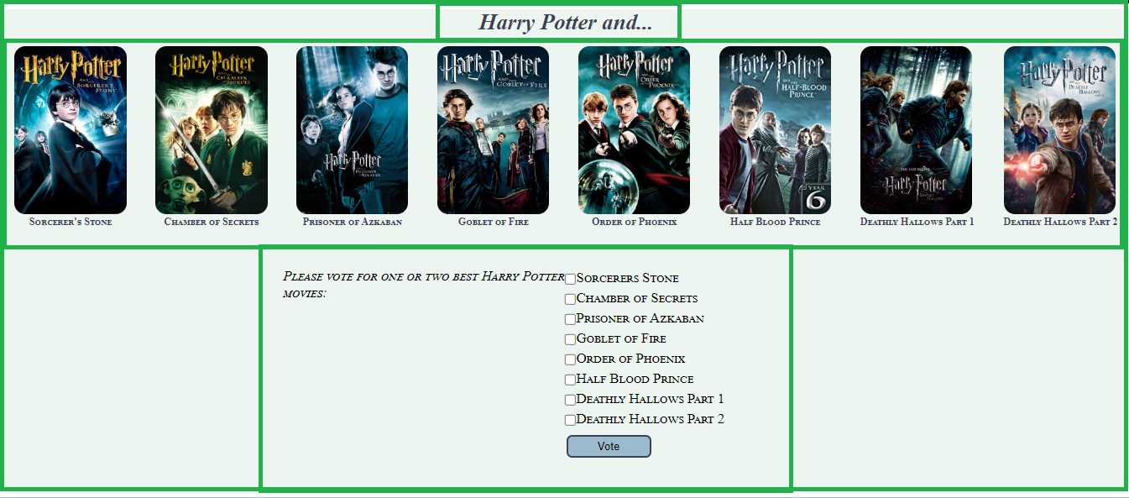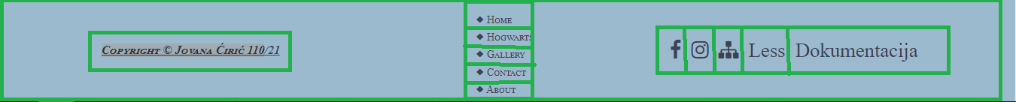

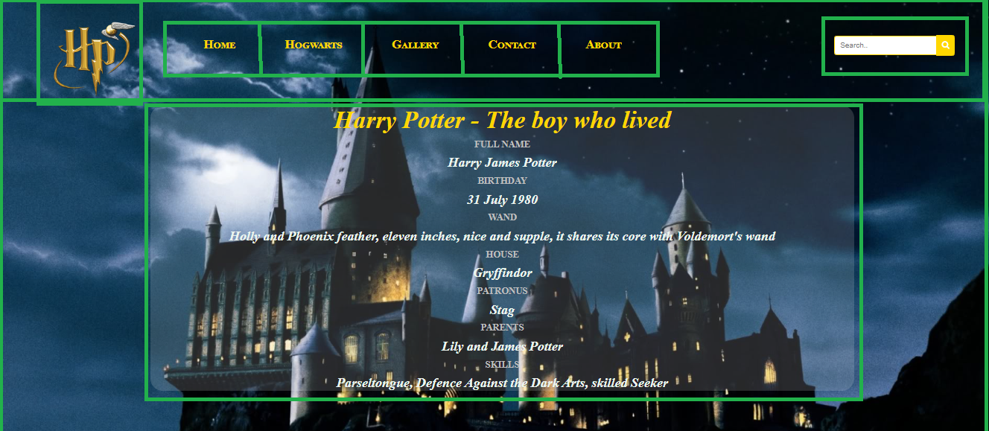

<!DOCTYPE html>

<html>

   <head>

      <title>Pottermania</title>

      <meta charset="UTF-8"/>

      <meta name="author" content="Jovana Ciric 110/21"/>

      <meta name="keywords" content="Harry Potter, Hogwarts, Magic"/>

      <meta name="language" content="English"/>

      <meta name="viewport" content="width=device-width, initial-scale=1.0" />

      <link rel="stylesheet" type="text/css" href="assets/css/style.css" />

      <link rel="stylesheet" type="text/css" href="assets/css/main.css" />

      <link rel="icon" href="assets/images/favicon.ico" />

      <link rel="stylesheet" href="https://cdnjs.cloudflare.com/ajax/libs/font-awesome/4.7.0/css/font-awesome.min.css" />

      <link href="http://www.fontsaddict.com/font/harry-potter.html" rel="stylesheet" />

   </head>

   <body>

      <div id="omot">

         <header>

            <div id="pozadina">

               <div id="glavni">

                  <div id="logo">

                     <a href="index.html"><img src="assets/images/logo.png" alt="Logo"></a>

                  </div>

                  <div id="meni" class="topnav">

                  </div>

                  <div id="pretraga">

                     <form action="#" method="GET">

                        <input type="text" name="tbPretraga" id="tbPretraga" placeholder="Search.." />

                        <button type="submit" id="tbDugme"> <i class="fa fa-search"></i> </button>

                     </form>

                  </div>

                  <div class="cleaner"></div>

                  <div id="more">

                     <h1 id="naslov">Harry Potter - The boy who lived</h1>

                     <dl id="informacije">

                        <dt class="info">FULL NAME</dt>

                        <dd class="podaci">

                           <p>Harry James Potter</p>

                        </dd>

                        <dt class="info">BIRTHDAY</dt>

                        <dd class="podaci">

                           <p>31 July 1980</p>

                        </dd>

                        <dt class="info">WAND</dt>

                        <dd class="podaci">

                           <p>Holly and Phoenix feather, eleven inches, nice and supple, it shares its core with Voldemort's wand</p>

                        </dd>

                        <dt class="info">HOUSE</dt>

                        <dd class="podaci">

                           <p>Gryffindor</p>

                        </dd>

                        <dt class="info">PATRONUS</dt>

                        <dd class="podaci">

                           <p>Stag</p>

                        </dd>

                        <dt class="info">PARENTS</dt>

                        <dd class="podaci">

                           <p>Lily and James Potter</p>

                        </dd>

                        <dt class="info">SKILLS</dt>

                        <dd class="podaci">

                           <p>Parseltongue, Defence Against the Dark Arts, skilled Seeker</p>

                        </dd>

                     </dl>

                  </div>

               </div>

            </div>

         </header>

         <main>

            <h2 id="delovi"> Harry Potter and... </h2>

            <div id="parts">

            </div>

            <div class="questionMovie">

               <div class="bestMovies">

                  <div id = "vote-result" class="movieVote">

                     <span><i>Please vote for one or two best Harry Potter movies: </i></span><br/><br/>

                     <div id="vote"></div>

                  </div>

                  <div id="movies-form" class="movieVote">

                     <div id="moviesList"></div>

                     <button type="button" id="btnVote" class="dugme">Vote</button>

                  </div>

                  <div class="cleaner"></div>

               </div>

            </div>

         </main>

         <footer>

            <div id="autor">

               <h3 id="naslovFuter"><a href="about.html">Copyright &copy Jovana Ćirić 110/21</a></h3>

            </div>

            <div id="meniFuter">

            </div>

            <div id="social">

               <ul>

                  <li><a href="https://www.facebook.com/harrypottermovie/" target="_blank"> <span class="fa fa-facebook"></span></a></li>

                  <li><a href="https://www.instagram.com/harrypotterfilm/" target="_blank"> <span class="fa fa-instagram"></span></a></li>

                  <li><a href="assets/information/sitemap.xml" target="_blank"> <i class="fa fa-sitemap"></i></a></li>

                  <li><a href="assets/css/less.txt" target="_blank">Less</a></li>

                  <li><a href="assets/information//dokumentacija.pdf" target="_blank">Dokumentacija</i></a></li>

               </ul>

            </div>

         </footer>

      </div>

      <script src="https://ajax.googleapis.com/ajax/libs/jquery/1.11.2/jquery.min.js"></script>

      <script type="text/javascript" src="assets/js/index.js"></script>

      <script type="text/javascript" src="assets/js/main.js"></script>

   </body>

</html>

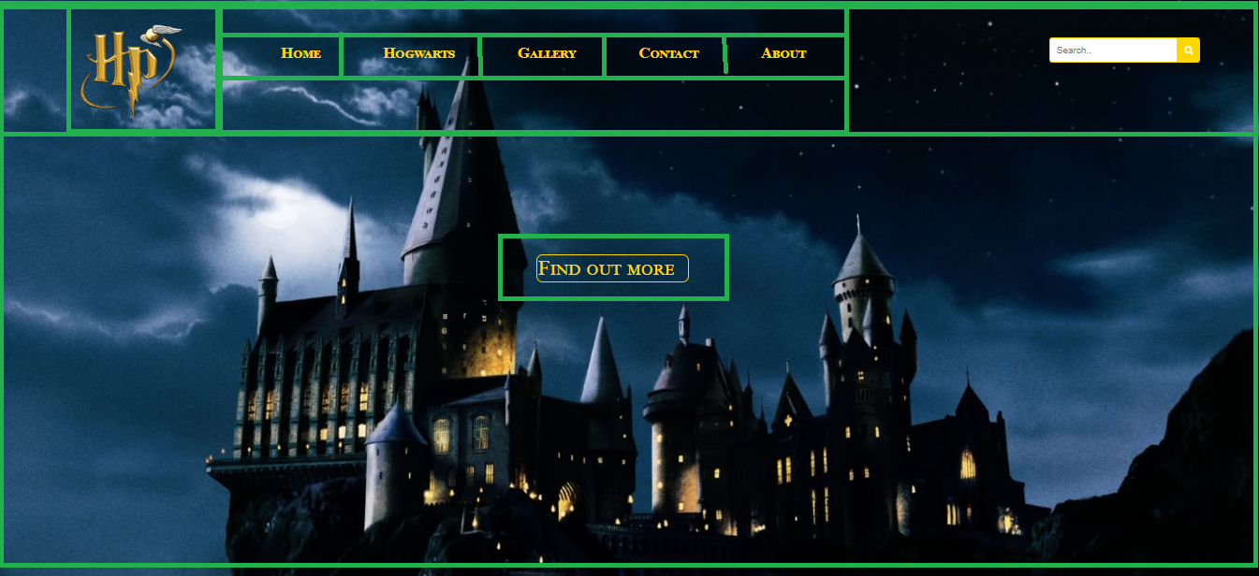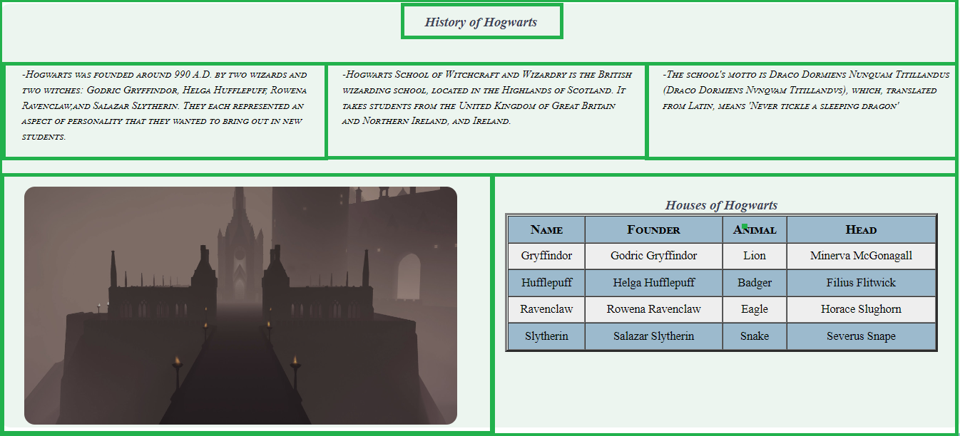

<!DOCTYPE html>

<html>

   <head>

      <title>Pottermania</title>

      <meta charset="UTF-8"/>

      <meta name="author" content="Jovana Ciric 110/21"/>

      <meta name="keywords" content="Harry Potter, Hogwarts, Magic"/>

      <meta name="language" content="English"/>

      <meta name="viewport" content="width=device-width, initial-scale=1.0">

      <link rel="stylesheet" type="text/css" href="assets/css/hogwarts.css">

      <link rel="stylesheet" type="text/css" href="assets/css/main.css" />

      <link rel="icon" href="assets/images/favicon.ico">

      <link rel="stylesheet" href="https://cdnjs.cloudflare.com/ajax/libs/font-awesome/4.7.0/css/font-awesome.min.css">

      <link href="http://www.fontsaddict.com/font/harry-potter.html" rel="stylesheet">

   </head>

   <body>

      <div id="omot">

         <header>

            <div id="pozadina">

               <div id="glavni">

                  <div id="logo">

                     <a href="index.html"><img src="assets/images/logo.png" alt="Logo"></a>

                  </div>

                  <div id="meni" class="topnav">

                  </div>

                  <div id="pretraga">

                     <form action="#" method="GET">

                        <input type="text" name="tbPretraga" id="tbPretraga" placeholder="Search.." />

                        <button type="submit" id="tbDugme"> <i class="fa fa-search"></i> </button>

                     </form>

                  </div>

                  <div class="cleaner"></div>

                  <div id="prebaci">

                     <a href="#fact" id="dugmes">Find out more</a>

                  </div>

               </div>

            </div>

         </header>

         <main>

            <section id="fact">

               <h3>History of Hogwarts</h3>

               <div class="row" id="description">

               </div>

               <div class="row">

                  <div class="col-1-of-2 slika">

                     <img src="assets/images/ulaz.jpg" alt="Entrance">

                  </div>

                  <div class="col-1-of-2">

                     <h3>Houses of Hogwarts</h3>

                     <table border="5px" width="100%" cellpadding="1px" cellspacing="1px" id="kuca">

                     </table>

                  </div>

                  <div class="cleaner">

                  </div>

               </div>

            </section>

         </main>

         <footer>

            <div id="autor">

               <h3 id="naslovFuter"><a href="about.html">Copyright &copy Jovana Ćirić 110/21</a></h3>

            </div>

            <div id="meniFuter">

            </div>

            <div id="social">

               <ul>

                  <li><a href="https://www.facebook.com/harrypottermovie/" target="_blank"> <i class="fa fa-facebook"></i></a></li>

                  <li><a href="https://www.instagram.com/harrypotterfilm/" target="_blank"> <i class="fa fa-instagram"></i></a></li>

                  <li><a href="assets/information/sitemap.xml" target="_blank"> <i class="fa fa-sitemap"></i></a></li>

                  <li><a href="assets/css/less.txt" target="_blank">Less</a></li>

                  <li><a href="assets/information/dokumentacija.pdf" target="_blank">Dokumentacija</i></a></li>

               </ul>

            </div>

         </footer>

      </div>

      <script src="https://ajax.googleapis.com/ajax/libs/jquery/1.11.2/jquery.min.js"></script>

      <script type="text/javascript" src="assets/js/main.js"></script>

      <script type="text/javascript" src="assets/js/hogwarts.js"></script>

   </body>

</html>

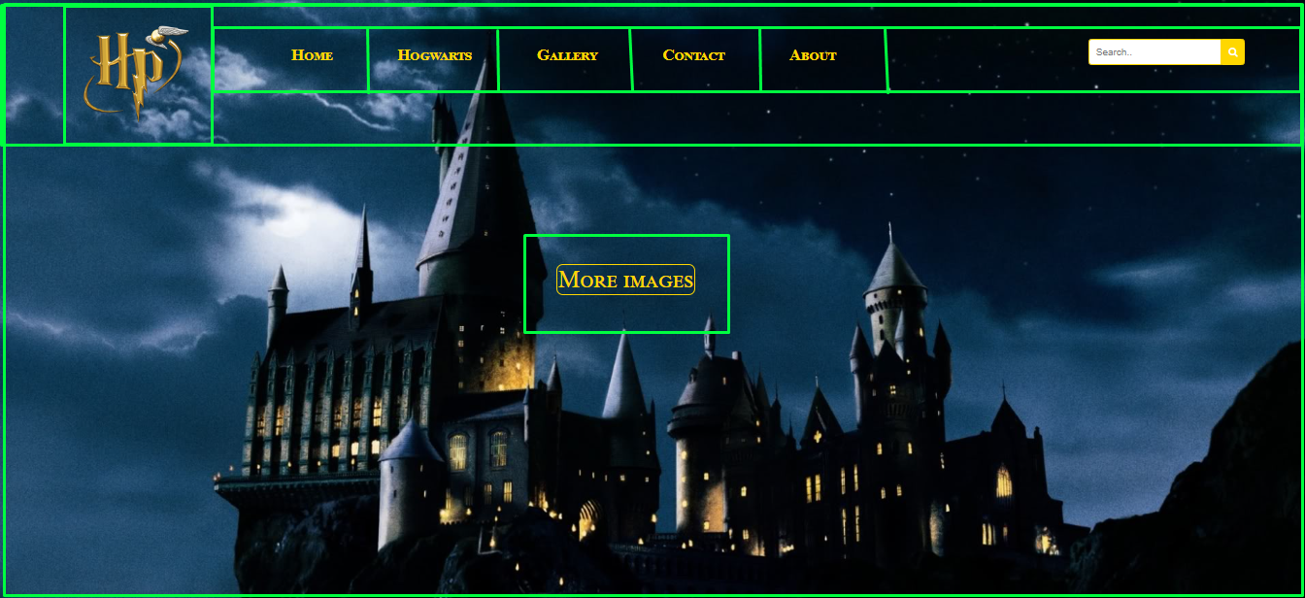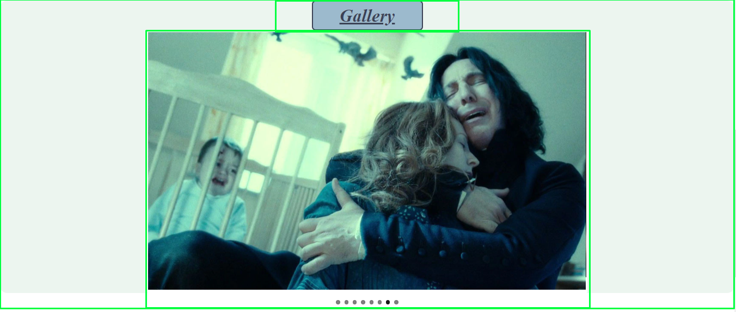

<!DOCTYPE html>

<html>

   <head>

      <title>Pottermania</title>

      <meta charset="UTF-8"/>

      <meta name="author" content="Jovana Ciric 110/21"/>

      <meta name="keywords" content="Harry Potter, Hogwarts, Magic"/>

      <meta name="language" content="English"/>

      <meta name="viewport" content="width=device-width, initial-scale=1.0">

      <link rel="stylesheet" type="text/css" href="assets/css/gallery.css">

      <link rel="stylesheet" type="text/css" href="assets/css/main.css" />

      <link rel="stylesheet" type="text/css" href="plugin/FlexSlider/flexslider.css" />

      <link rel="icon" href="assets/images/favicon.ico">

      <link rel="stylesheet" href="https://cdnjs.cloudflare.com/ajax/libs/font-awesome/4.7.0/css/font-awesome.min.css">

      <link href="http://www.fontsaddict.com/font/harry-potter.html" rel="stylesheet">

   </head>

   <body>

      <div id="omot">

         <header>

            <div id="pozadina">

               <div id="glavni">

                  <div id="logo">

                     <a href="index.html"><img src="assets/images/logo.png" alt="Logo"></a>

                  </div>

                  <div id="meni" class="topnav">

                  </div>

                  <div id="pretraga">

                     <form action="#" method="GET">

                        <input type="text" name="tbPretraga" id="tbPretraga" placeholder="Search.." />

                        <button type="submit" id="tbDugme"> <i class="fa fa-search"></i> </button>

                     </form>

                  </div>

                  <div class="cleaner"></div>

                  <div id="prebaci">

                     <a href="#naslov" id="dugmes">More images</a>

                  </div>

               </div>

            </div>

         </header>

         <main>

            <div id="naslov">

               <h1>Gallery</h1>

            </div>

            <div id="slider" class="pictures-slide">

               <div class="flexslider" id="inputImg">

               </div>

            </div>

         </main>

         <footer>

            <div id="autor">

               <h3 id="naslovFuter"><a href="about.html">Copyright &copy Jovana Ćirić 110/21</a></h3>

            </div>

            <div id="meniFuter">

            </div>

            <div id="social">

               <ul>

                  <li><a href="https://www.facebook.com/harrypottermovie/" target="_blank"> <i class="fa fa-facebook"></i></a></li>

                  <li><a href="https://www.instagram.com/harrypotterfilm/" target="_blank"> <i class="fa fa-instagram"></i></a></li>

                  <li><a href="assets/information/sitemap.xml" target="_blank"> <i class="fa fa-sitemap"></i></a></li>

                  <li><a href="assets/css/less.txt" target="_blank">Less</a></li>

                  <li><a href="assets/information/dokumentacija.pdf" target="_blank">Dokumentacija</i></a></li>

               </ul>

            </div>

         </footer>

      </div>

      <script src="https://ajax.googleapis.com/ajax/libs/jquery/1.11.2/jquery.min.js"></script>

      <script src="plugin/FlexSlider/jquery.flexslider-min.js"></script>

      <script type="text/javascript" src="assets/js/main.js"></script>

      <script type="text/javascript" src="assets/js/gallery.js"></script>

   </body>

</html>

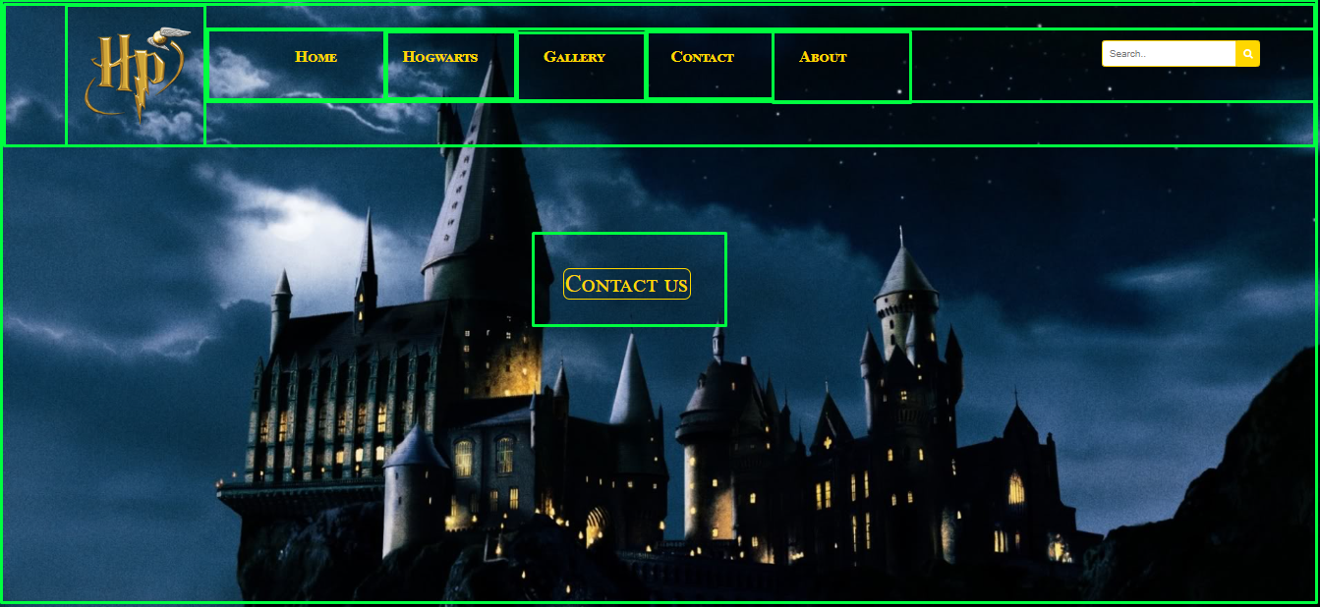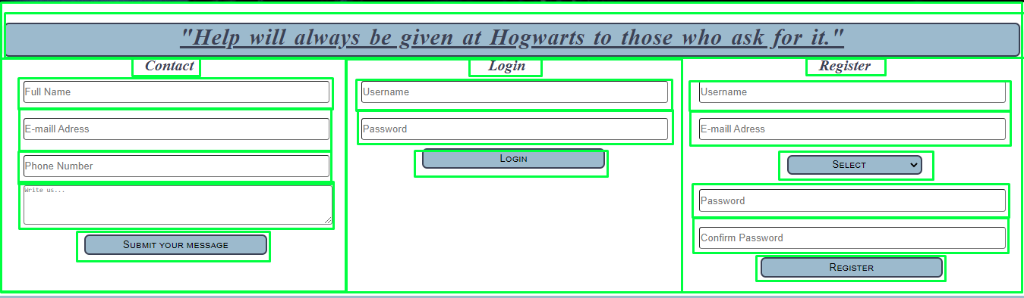

<!DOCTYPE html>

<html>

   <head>

      <title>Pottermania</title>

      <meta charset="UTF-8"/>

      <meta name="author" content="Jovana Ciric 110/21"/>

      <meta name="keywords" content="Harry Potter, Hogwarts, Magic"/>

      <meta name="language" content="English"/>

      <meta name="viewport" content="width=device-width, initial-scale=1.0">

      <link rel="stylesheet" type="text/css" href="assets/css/contact.css">

      <link rel="stylesheet" type="text/css" href="assets/css/main.css" />

      <link rel="icon" href="assets/images/favicon.ico">

      <link rel="stylesheet" href="https://cdnjs.cloudflare.com/ajax/libs/font-awesome/4.7.0/css/font-awesome.min.css">

      <link href="http://www.fontsaddict.com/font/harry-potter.html" rel="stylesheet">

   </head>

   <body>

      <div id="omot">

         <header>

            <div id="pozadina">

               <div id="glavni">

                  <div id="logo">

                     <a href="index.html"><img src="assets/images/logo.png" alt="Logo"></a>

                  </div>

                  <div id="meni" class="topnav">

                  </div>

                  <div id="pretraga">

                     <form action="#" method="GET">

                        <input type="text" name="tbPretraga" id="tbPretraga" placeholder="Search.." />

                        <button type="submit" id="tbDugme"> <i class="fa fa-search"></i> </button>

                     </form>

                  </div>

                  <div class="cleaner"></div>

                  <div id="prebaci">

                     <a href="#naslov" id="dugmes">Contact us</a>

                  </div>

               </div>

            </div>

         </header>

         <main>

            <div id="naslov">

               <h1>"Help will always be given at Hogwarts to those who ask for it."</h1>

            </div>

            <div class="form-div">

               <h2>Contact</h2>

               <form onsubmit="return false" id="contactForm">

                  <input type="text" placeholder="Full Name" class="polja" id="fullName"></br></br>

                  <input type="text" placeholder="E-maill Adress" class="polja" id="emailContact"></br></br>

                  <input type="text" placeholder="Phone Number" class="polja" id="phoneContact"></br></br>

                  <textarea cols="47" rows="5" class="write-text" placeholder="Write us..." id="textContact"></textarea></br></br>

                  <input type="submit" name="posalji" value="Submit your message" id="submitContact" class="dugme">

               </form>

               <div id="validInfo" class="show-validated">

               </div>

            </div>

            <div class="form-div">

               <h2>Login</h2>

               <form onsubmit="return false" id="loginForm">

                  <input type="text" placeholder="Username" class="polja" id="usernameLogin"></br></br>

                  <input type="password" placeholder="Password" class="polja" id="passwordLogin"></br></br>

                  <button type="submit" class="dugme" id="btnLogin">Login</button>

               </form>

               <div id="validLogin" class="show-validated">

               </div>

            </div>

            <div class="form-div">

               <h2>Register</h2>

               <form onsubmit="return false" id="registerForm">

                  <input type="text" placeholder="Username" class="polja" id="usernameRegister"></br></br>

                  <input type="text" placeholder="E-maill Adress" class="polja" id="emailRegister"></br></br>

                  <input type="password" placeholder="Password" class="polja" id="passwordRegister"></br></br>

                  <input type="password" placeholder="Confirm Password" class="polja" id="confPasswordRegister"></br></br>

                  <button type="submit" class="dugme" id="btnRegister">Register</button>

               </form>

               <div id="validReg" class="show-validated">

               </div>

            </div>

         </main>

         <footer>

            <div id="autor">

               <h3 id="naslovFuter"><a href="about.html">Copyright &copy Jovana Ćirić 110/21</a></h3>

            </div>

            <div id="meniFuter">

            </div>

            <div id="social">

               <ul>

                  <li><a href="https://www.facebook.com/harrypottermovie/" target="_blank"> <i class="fa fa-facebook"></i></a></li>

                  <li><a href="https://www.instagram.com/harrypotterfilm/" target="_blank"> <i class="fa fa-instagram"></i></a></li>

                  <li><a href="assets/information/sitemap.xml" target="_blank"> <i class="fa fa-sitemap"></i></a></li>

                  <li><a href="assets/css/less.txt" target="_blank">Less</a></li>

                  <li><a href="assets/information/dokumentacija.pdf" target="_blank">Dokumentacija</i></a></li>

               </ul>

            </div>

         </footer>

      </div>

      <script src="https://ajax.googleapis.com/ajax/libs/jquery/1.11.2/jquery.min.js"></script>

      <script type="text/javascript" src="assets/js/main.js"></script>

      <script type="text/javascript" src="assets/js/contact.js"></script>

   </body>

</html>

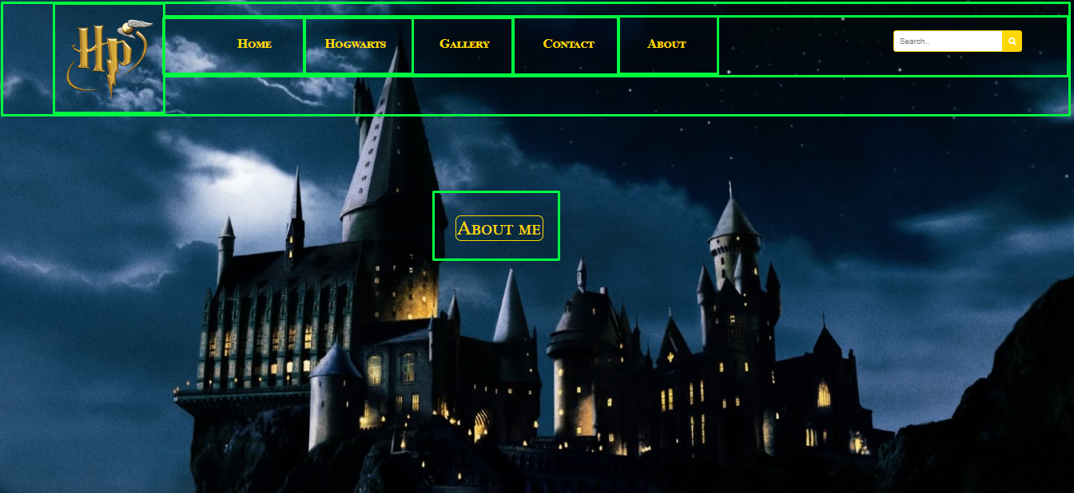<!DOCTYPE html>

<html>

   <head>

      <title>Pottermania</title>

      <meta charset="UTF-8"/>

      <meta name="author" content="Jovana Ciric 110/21"/>

      <meta name="keywords" content="Harry Potter, Hogwarts, Magic"/>

      <meta name="language" content="English"/>

      <meta name="viewport" content="width=device-width, initial-scale=1.0">

      <link rel="stylesheet" type="text/css" href="assets/css/about.css">

      <link rel="stylesheet" type="text/css" href="assets/css/main.css" />

      <link rel="icon" href="assets/images/favicon.ico">

      <link rel="stylesheet" href="https://cdnjs.cloudflare.com/ajax/libs/font-awesome/4.7.0/css/font-awesome.min.css">

      <link href="http://www.fontsaddict.com/font/harry-potter.html" rel="stylesheet">

   </head>

   <body>

      <div id="omot">

         <header>

            <div id="pozadina">

               <div id="glavni">

                  <div id="logo">

                     <a href="index.html"><img src="assets/images/logo.png" alt="Logo"></a>

                  </div>

                  <div id="meni" class="topnav">

                  </div>

                  <div id="pretraga">

                     <form action="#" method="GET">

                        <input type="text" name="tbPretraga" id="tbPretraga" placeholder="Search.." />

                        <button type="submit" id="tbDugme"> <i class="fa fa-search"></i> </button>

                     </form>

                  </div>

                  <div class="cleaner"></div>

                  <div id="prebaci">

                     <a href="#author" id="dugmes">About me</a>

                  </div>

               </div>

            </div>

         </header>

         <main>

            <div id="author">

               <div id="levo">

                  <img src="assets/images/autor.jpg" id="ja" alt="Author" class="authorImg"/>

               </div>

               <div id="desno">

                  <h1>About me:</h1>

                  <p>My name is Jovana Ćirić (110/21). I am 23 years old and I live in Obrenovac. I'm studying at

                     "Visoka ICT škola" in Belgrade. I would like to become a software developer. Here you can check out my

                     <a class="link" href="https://jovana-ciric-portfolio.netlify.app/" target="_blank">portfolio.</a><br/><br/>

                     Or reach me Via:

                     <a class="link" href="https://www.linkedin.com/" target="_blank">LinkedIn</a>

                  </p>

                  <p>Favourite quote from Harry Potter movies: <i>"After all this time? Always."</i></p>

               </div>

            </div>

         </main>

         <footer>

            <div id="autor">

               <h3 id="naslovFuter"><a href="about.html">Copyright &copy Jovana Ćirić 110/21</a></h3>

            </div>

            <div id="meniFuter">

            </div>

            <div id="social">

               <ul>

                  <li><a href="https://www.facebook.com/harrypottermovie/" target="_blank"> <i class="fa fa-facebook"></i></a></li>

                  <li><a href="https://www.instagram.com/harrypotterfilm/" target="_blank"> <i class="fa fa-instagram"></i></a></li>

                  <li><a href="assets/information/sitemap.xml" target="_blank"> <i class="fa fa-sitemap"></i></a></li>

                  <li><a href="assets/css/less.txt" target="_blank">Less</a></li>

                  <li><a href="assets/information/dokumentacija.pdf" target="_blank">Dokumentacija</i></a></li>

               </ul>

            </div>

         </footer>

      </div>

      <script src="https://ajax.googleapis.com/ajax/libs/jquery/1.11.2/jquery.min.js"></script>

      <script type="text/javascript" src="assets/js/main.js"></script>

   </body>

</html>

# 2. Organizacija

2.1 Organizacija sajta

ABOUT

GALLERY

CONTACT

HOGWARTS

INDEX

2.2. Mapa sajta

<?xml version="1.0" encoding="UTF-8"?>

<urlset xmlns="http://www.sitemaps.org/schemas/sitemap/0.9">

<url>

  <loc>https://jovanac998.github.io/Pottermania/index.html</loc>

  <lastmod>2022-12-12T19:41:45+00:00</lastmod>

  <priority>1.00</priority>

</url>

<url>

  <loc>https://jovanac998.github.io/Pottermania/hogwarts.html</loc>

  <lastmod>2022-12-12T19:41:45+00:00</lastmod>

  <priority>0.80</priority>

</url>

<url>

  <loc>https://jovanac998.github.io/Pottermania/gallery.html</loc>

  <lastmod>2022-12-12T19:41:45+00:00</lastmod>

  <priority>0.80</priority>

</url>

<url>

  <loc>https://jovanac998.github.io/Pottermania/contact.html</loc>

  <lastmod>2022-12-12T19:41:45+00:00</lastmod>

  <priority>0.70</priority>

</url>

<url>

  <loc>https://jovanac998.github.io/Pottermania/about.html</loc>

  <lastmod>2022-12-12T19:41:45+00:00</lastmod>

  <priority>0.60</priority>

</url>

</urlset>

2.3. Stranice

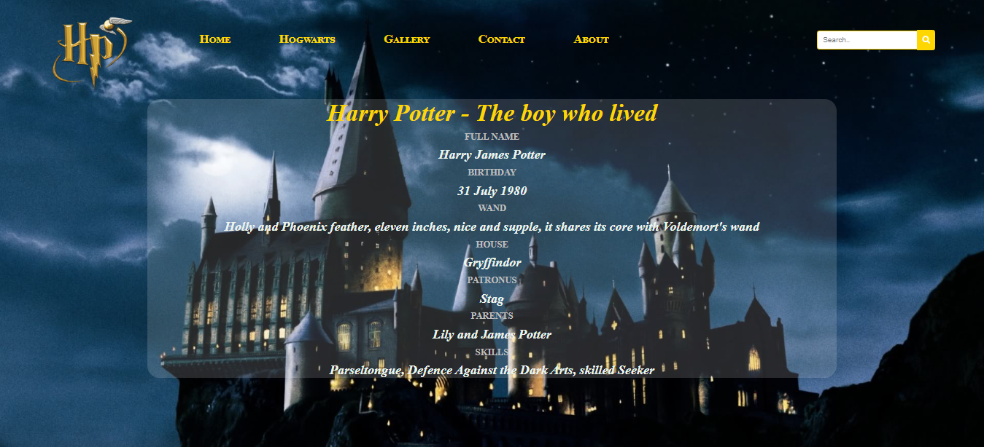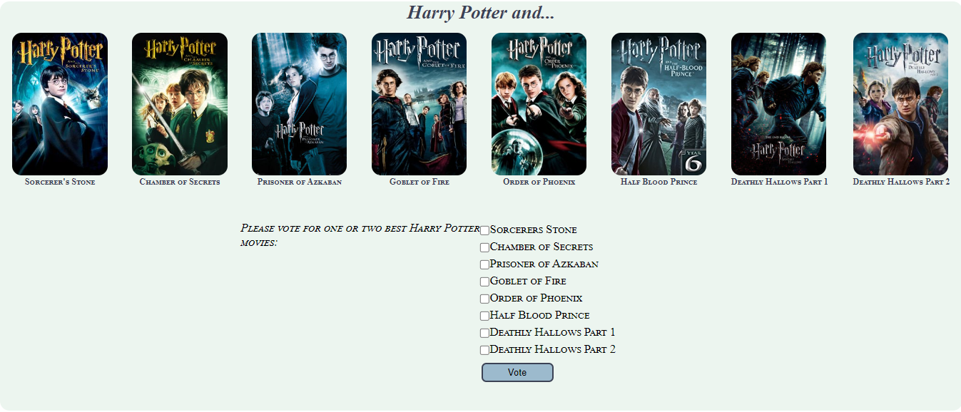

Index.html – Na staranici index.html se nalaze informacije o Hari Poteru, dinamički su ispisani nazivi filmova I prikazane slike. Takođe nalazi se dinamički napisana checkbox lista za glasanje, koja poseduje funkcionalnost u zavisnosti od tačnosti čekiranja. Takođe dinamički ispisani meni u hederu i futeru.

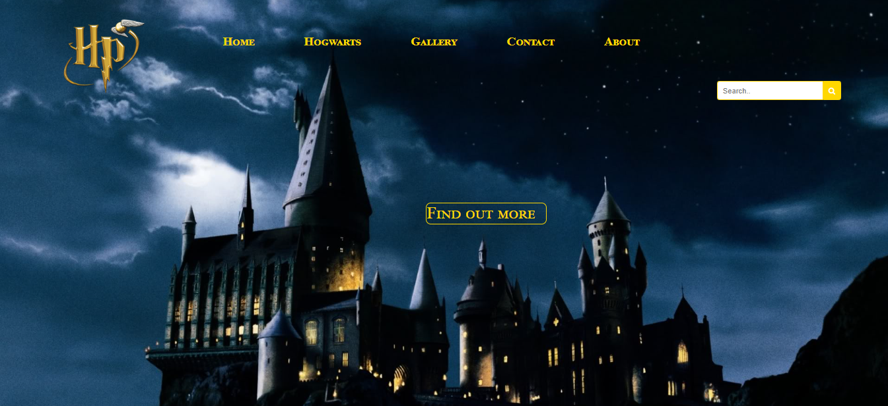

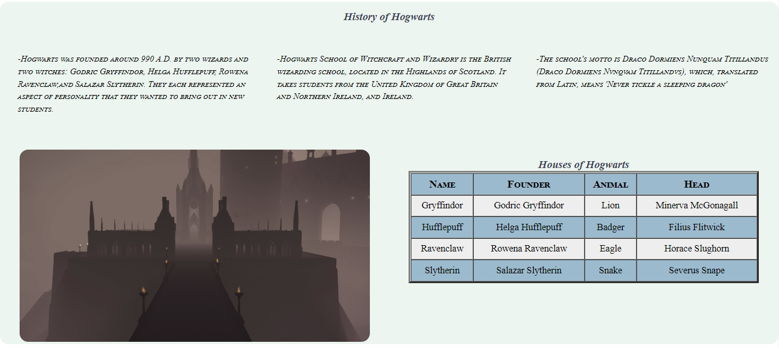



Hogworts.html – Na stranici hogworts-html, nakon klika na dugme “Find out more” spušta na određeni section gde je dinamički ispisana istorija o Hogworts-u, dinamički ispisana tabela I urađena zebra na tabeli preko JQuery-a. . Takođe dinamički ispisani meni u hederu i futeru

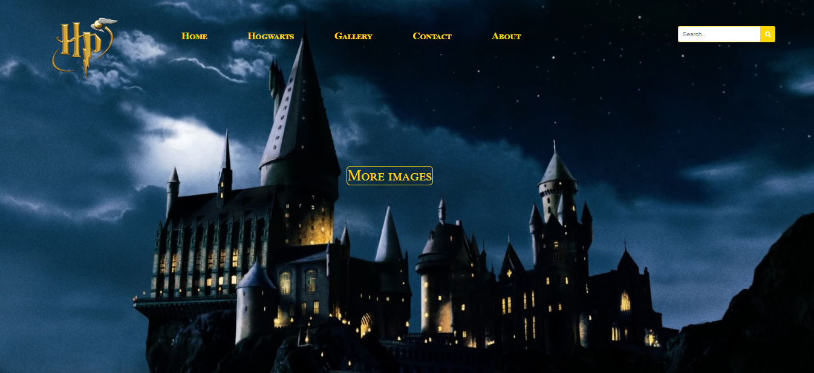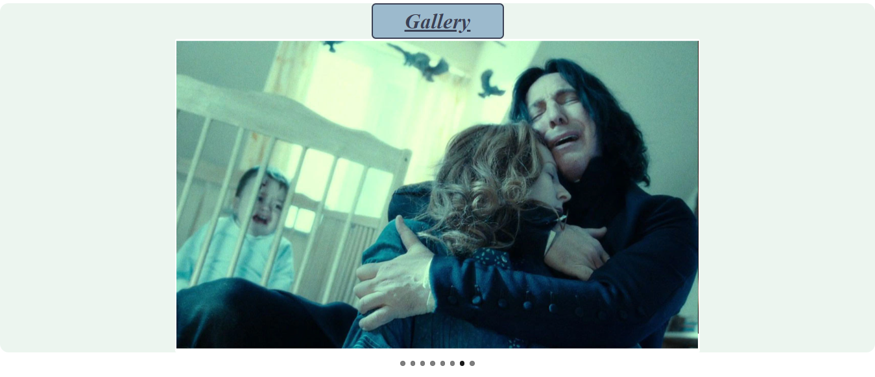

Gallery.html – Na stranisi gallery.html se takođe nalazi dugme za spustanje na određeni section, gde je pomoću Flexslider plugin-a dinamički prikazane slike, koje se menjaju na svakih 5 sekundi, a pomći bullet-a se mogu I ručno promeniti. . Takođe dinamički ispisani meni u hederu i futeru

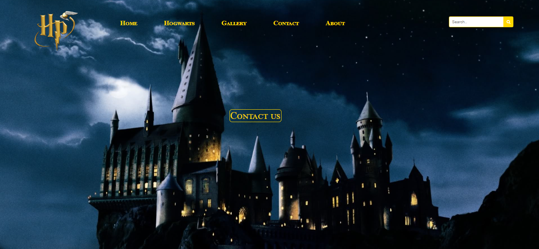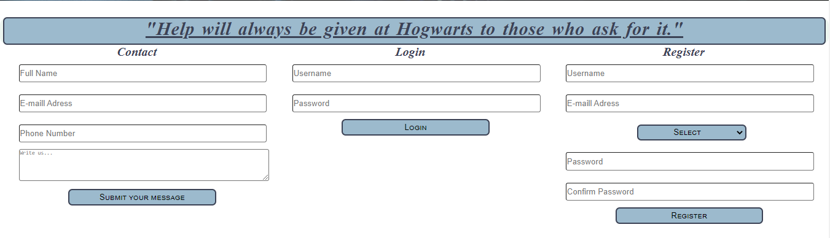

Contact.html – Na stranici contact.html se nakon klika na dugme spusta na određeni section, gde imamo tri forme. Klikom na dugmad za submit-ovanje formi dolazi do validacije unetih vrednosti. U zavisnotsti od toga u kakvom format su uneti podaci, u neuređenoj listi ispod dugmadi će se ispisati vrednosti podataka, ukoliko su zadovoljavajući, u suprotnom, na istom mestu će se ispisati poruke sa greškama. Takođe dinamički ispisani meni u hederu i futeru

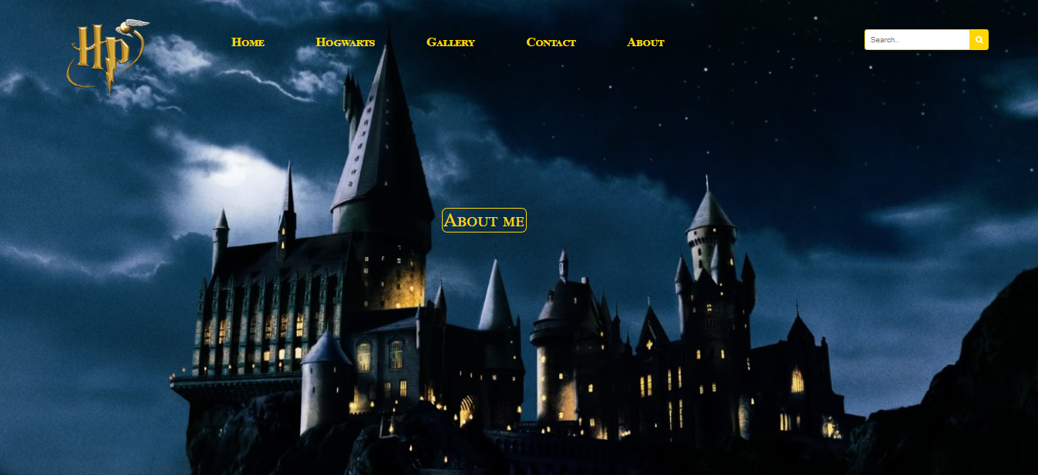

About.html – Na stranici about.html, nakon klika na dugme, spuštamo se do sectiona, gde su prikazane osnovne informacije o autoru sajta. Takođe dinamički ispisani meni u hederu i futeru.

**3. JS Kodovi**

Kod za main.js

window.onload=*function*(){

    populateMenu();

    document.querySelector(".icon").addEventListener("click", myFunction);

}

*function* myFunction() {

*var* x = document.getElementById("meni");

    if (x.className === "topnav") {

        x.className += " responsive";

    } else {

        x.className = "topnav";

    }

}

*function* populateMenu(){

*var* ispis="<ul>";

*var* ispisFuter = "<ul>";

*var* menu = ["Home","Hogwarts", "Gallery","Contact","About"];

    for (*let* i = 0; i < menu.length; i++) {

        if(menu[i].toLowerCase() == "home") {

            ispis+=`<li><a href="index.html">${menu[i]}</a></li>`

            ispisFuter += `<li><a href="index.html">&#x25C6 ${menu[i]}</a></li>`

        } else {

            ispis+=`<li><a href="${menu[i].toLowerCase()}.html">${menu[i]}</a></li>`

            ispisFuter += `<li><a href="${menu[i].toLowerCase()}.html">&#x25C6 ${menu[i]}</a></li>`

        }

    }

    ispis+='<li><a href="javascript:void(0);" class="icon"><span class="fa fa-bars"></span></a></li></ul>';

    ispisFuter += "</ul>"

    document.getElementById("meni").innerHTML=ispis;

    document.getElementById("meniFuter").innerHTML = ispisFuter;

}

Kod za index.js

$(document).ready(*function*() {

    loadMoivesChb();

    document.getElementById("btnVote").addEventListener("click",proveraGlasanja);

    loadMoviesImgAndTitles();

});

*function* loadMoivesChb(){

*var* movies = ["Sorcerers Stone", "Chamber of Secrets", "Prisoner of Azkaban", "Goblet of Fire", "Order of Phoenix", "Half Blood Prince", "Deathly Hallows Part 1", "Deathly Hallows Part 2"];

*var* movieList = "<ul>"

    for( *var* i=0; i < movies.length; i++) {

        movieList += "<li><input type='checkbox' value='" + movies[i] + "' name='chbxVote'>" + movies[i] + "<br></li>"

    }

    movieList += "</ul>"

    document.getElementById("moviesList").innerHTML = movieList;

}

*function* proveraGlasanja() {

*var* glasovi = document.getElementsByName("chbxVote");

*var* izabrano = "";

*var* vote = 0;

    for(*var* i=0; i < glasovi.length ; i++){

        if(glasovi[i].checked) {

            vote++;

            izabrano += "<i><p>Your choice "+ vote + ": " + glasovi[i].value + "</p></i>";

        }

    }

    if(vote > 2) {

        izabrano = "<p><b>You chose more than you can.</b></p>"

    } else if(vote == 0){

        izabrano = "<p><b>Choose two movies.</b></p>"

    } else {

        $("#btnVote").hide();

    }

    document.getElementById("vote").innerHTML = izabrano;

}

*function* loadMoviesImgAndTitles() {

*let* movies = [

        {src: "prvi", title:"Sorcerer's Stone"},

        {src: "drugi", title:"Chamber of Secrets"},

        {src: "treci", title:"Prisoner of Azkaban"},

        {src: "cetvrti", title:"Goblet of Fire"},

        {src: "peti", title:"Order of Phoenix"},

        {src: "sesti", title:"Half Blood Prince"},

        {src: "sedmi", title:"Deathly Hallows Part 1"},

        {src: "sedmi2", title:"Deathly Hallows Part 2"}

    ];

*var* ispis = "";

        for(*let* i = 0; i < movies.length; i++) {

                ispis+= `<figure class="slika">

                <img src="assets/images/${movies[i].src}.jpg" alt="Movie Part"/>

                <figcaption class="part">${movies[i].title}</figcaption>

                 </figure>`

        }

        document.getElementById("parts").innerHTML=ispis;

}

Kod za Hogwarts.js

$(document).ready(*function*() {

    populateDescription();

    makeTable();

});

*function* populateDescription (){

*var* text= [

        "-Hogwarts was founded around 990 A.D. by two wizards and two witches: Godric Gryffindor, Helga Hufflepuff, Rowena Ravenclaw,and Salazar Slytherin. They each represented an aspect of personality that they wanted to bring out in new students.",

        "-Hogwarts School of Witchcraft and Wizardry is the British wizarding school, located in the Highlands of Scotland. It takes students from the United Kingdom of Great Britain and Northern Ireland, and Ireland.",

        "-The school's motto is Draco Dormiens Nunquam Titillandus (Draco Dormiens Nvnqvam Titillandvs), which, translated from Latin, means 'Never tickle a sleeping dragon'"

    ]

*var* ispis="";

    for (*let* i = 0; i < text.length; i++) {

        ispis+=`<div class = "col"><p class ="text"> ${text[i]}</p></div>`

    }

    document.getElementById("description").innerHTML=ispis;

}

*function* makeTable() {

*let* houses = [

        {name: "Gryffindor", founder: "Godric Gryffindor", animal:"Lion", head:"Minerva McGonagall"},

        {name:"Hufflepuff", founder:"Helga Hufflepuff",animal:"Badger",head:"Filius Flitwick"},

        {name:"Ravenclaw",founder:"Rowena Ravenclaw",animal:"Eagle",head:"Horace Slughorn"},

        {name:"Slytherin",founder:"Salazar Slytherin",animal:"Snake",head:"Severus Snape"}

    ];

*var* ispis ="<tr><th>Name</th><th>Founder</th><th>Animal</th><th>Head</th></tr>";

    for (*let* i = 0; i < houses.length; i++) {

        ispis+=`<tr>

            <td>${houses[i].name}</td>

            <td>${houses[i].founder}</td>

            <td>${houses[i].animal}</td>

            <td>${houses[i].head}</td>

            </tr>`

    }

    document.getElementById("kuca").innerHTML=ispis;

    $('table tbody tr:even').css('background-color','#9CBACD')

    $('table tbody tr:odd').css('background-color','#eee')

}

Kod za gallery.js

$(document).ready(*function*() {

    insertImg()

    $('.flexslider').flexslider({

      animation: "slide"

    });

});

*function* insertImg() {

*let* imgList=[

        {src: "hari", alt:"Harry Potter"},

        {src: "battle", alt:"Harry Potter"},

        {src: "patronus", alt:"Patronus"},

        {src: "hrjh", alt:"Harry Hermione Ron"},

        {src: "lordvoldemort", alt:"Lord Voldemort"},

        {src: "lupin", alt:"Proffesor Lupin"},

        {src: "snape", alt:"Proffesor Snape"},

        {src: "dumbledore", alt:"Dumbledore"},

    ];

*let* ispis= '<ul class="slides">'

    for (*let* i = 0; i < imgList.length; i++) {

        ispis+= `<li><img src="assets/images/${imgList[i].src}.jpg" alt="${imgList[i].alt}"></li>`

    }

    ispis+="</ul>"

    document.getElementById("inputImg").innerHTML=ispis;

}

Kod za contact.js

$(document).ready(*function*() {

    loadHouses();

    document.getElementById("submitContact").addEventListener("click",proveraKontakt);

    document.getElementById("btnLogin").addEventListener("click", proveraLogin);

    document.getElementById("btnRegister").addEventListener("click", proveraRegister);

});

*var* reEmail = /^\w+([\.-]?\w+)*@\w+([\.-]?\w+)*(\.\w{2,3})+$/;

*var* reUsername = /^[a-zA-Z0-9]{3,30}$/;

*var* rePass = /^(?=.*?[A-Z])(?=.*?[a-z])(?=.*?[0-9])(?=.*?[.#?!@$%^&*-]).{8,}$/;

*function* proveraKontakt() {

*var* nameContact = document.getElementById("fullName");

*var* phoneContact = document.getElementById("phoneContact");

*var* textContact = document.getElementById("textContact");

*var* reName = /^[A-ZŠĐČĆŽ][a-zšđčćž]{1,11}(\s[A-ZŠĐČĆŽ][a-zšđčćž]{1,11})+$/;

*var* rePhone = /^\(?([0-9]{3})\)?[-. ]?([0-9]{3})[-. ]?([0-9]{4})$/;

*var* reText = /^[a-zA-Z0-9_ ]{3,}$/;

*var* nizGreske = [];

*var* nizOk = ["You have successfully sent a message: "];

    if(!reName.test(nameContact.value)) {

        nizGreske.push("You didn't enter the Name and Surname correctly!")

    } else {

        nizOk.push(nameContact.value);

    }

    if(!reEmail.test(emailContact.value)) {

        nizGreske.push("You didn't enter Email correctly!")

    } else {

        nizOk.push(emailContact.value);

    }

    if(!rePhone.test(phoneContact.value)) {

        nizGreske.push("You didn't enter Phone correctly!")

    } else {

        nizOk.push(phoneContact.value);

    }

    if(!reText.test(textContact.value)) {

        nizGreske.push("You didn't enter your message correctly! Your message needs to have at least 3 characters!")

    } else {

        nizOk.push(textContact.value);

    }

*var* lista = "<ul>";

    if(nizGreske != 0) {

        for(*var* i=0; i < nizGreske.length; i++) {

            lista += "<li style='color:#ff0000'>" + nizGreske[i] + "</li>"

        }

    } else {

        for(*var* i=0; i < nizOk.length; i++) {

            lista += "<li style='color:#48688a'>" + nizOk[i] + "</li>";

            $("#contactForm").trigger("reset");

        }

    }

    lista += "</ul>"

    $("#validInfo").html(lista);

}

*function* proveraLogin() {

*var* username = document.getElementById("usernameLogin");

*var* password = document.getElementById("passwordLogin");

*var* nizGreske = [];

*var* nizOk = [];

    if(!reUsername.test(username.value)) {

        nizGreske.push("You didn't enter Username correctly!")

    } else {

        nizOk.push(username.value);

    }

    if(!rePass.test(password.value)) {

        nizGreske.push("You didn't enter Password correctly!")

    } else {

        nizOk.push(password.value);

    }

*var* lista = "<ul>";

    if(nizGreske != 0) {

        for(*var* i=0; i < nizGreske.length; i++) {

            lista += "<li style='color:#ff0000'>" + nizGreske[i] + "</li>"

        }

    } else {

        lista = "<li style='color:#48688a'>You have successfully logged in!</li>"

    }

    lista += "</ul>";

    $("#loginForm").trigger("reset");

    $("#validLogin").html(lista);

}

*function* proveraRegister() {

*var* username = document.getElementById("usernameRegister");

*var* password = document.getElementById("passwordRegister");

*var* confPass = document.getElementById("confPasswordRegister");

*var* email = document.getElementById("emailRegister");

*var* houseDdl = document.getElementById("ddlHouses");

*var* selectedHouse = houseDdl.options[houseDdl.selectedIndex].value;

*var* nizGreske = [];

*var* nizOk = [];

    if(!reUsername.test(username.value)) {

        nizGreske.push("You didn't enter Username correctly. Username must be composed of letters or numbers with a length of 3 to 30 characters!")

    } else {

        nizOk.push("Your username is: " + username.value);

    }

    if(!reEmail.test(email.value)) {

        nizGreske.push("You didn't enter Email correctly!");

    } else {

        nizOk.push("Your email is: " + email.value);

    }

    if(selectedHouse == "0") {

        nizGreske.push("You didn't choose a house!");

    } else {

        nizOk.push("You choose the house: " + selectedHouse);

    }

    if(!rePass.test(password.value)) {

        nizGreske.push("You didn't enter Password correctly. Password must have a large letter, a number, a special character and mustn't be shorter than 8 characters!")

        password.value = "";

        confPass.value = "";

    } else if(password.value != confPass.value) {

        nizGreske.push("You didn't enter the same password!");

        password.value = "";

        confPass.value = "";

    }

*var* lista = "<ul>";

    if(nizGreske != 0) {

        for(*var* i=0; i < nizGreske.length; i++) {

            lista += "<li style='color:#ff0000'>" + nizGreske[i] + "</li>"

        }

    } else {

        for(*var* i=0; i < nizOk.length; i++) {

            lista += "<li style='color:#48688a'>" + nizOk[i] + "</li>"

        }

        $("#registerForm").trigger("reset");

    }

    lista += "</ul>"

    $("#validReg").html(lista);

}

*function* loadHouses() {

*var* houses = ["Gryffindor", "Hufflepuff", "Ravenclaw", "Slytherin"];

*var* ispis = "<select id='ddlHouses' class='houses-select'>";

    ispis += "<option value = 0>Select</option>";

    for(*var* i=0; i < houses.length; i++) {

        ispis += "<option value='" + houses[i] + "'>" + houses[i] + "</option>";

    }

    ispis += "</select></br></br>";

    $("#passwordRegister").before(ispis);

}